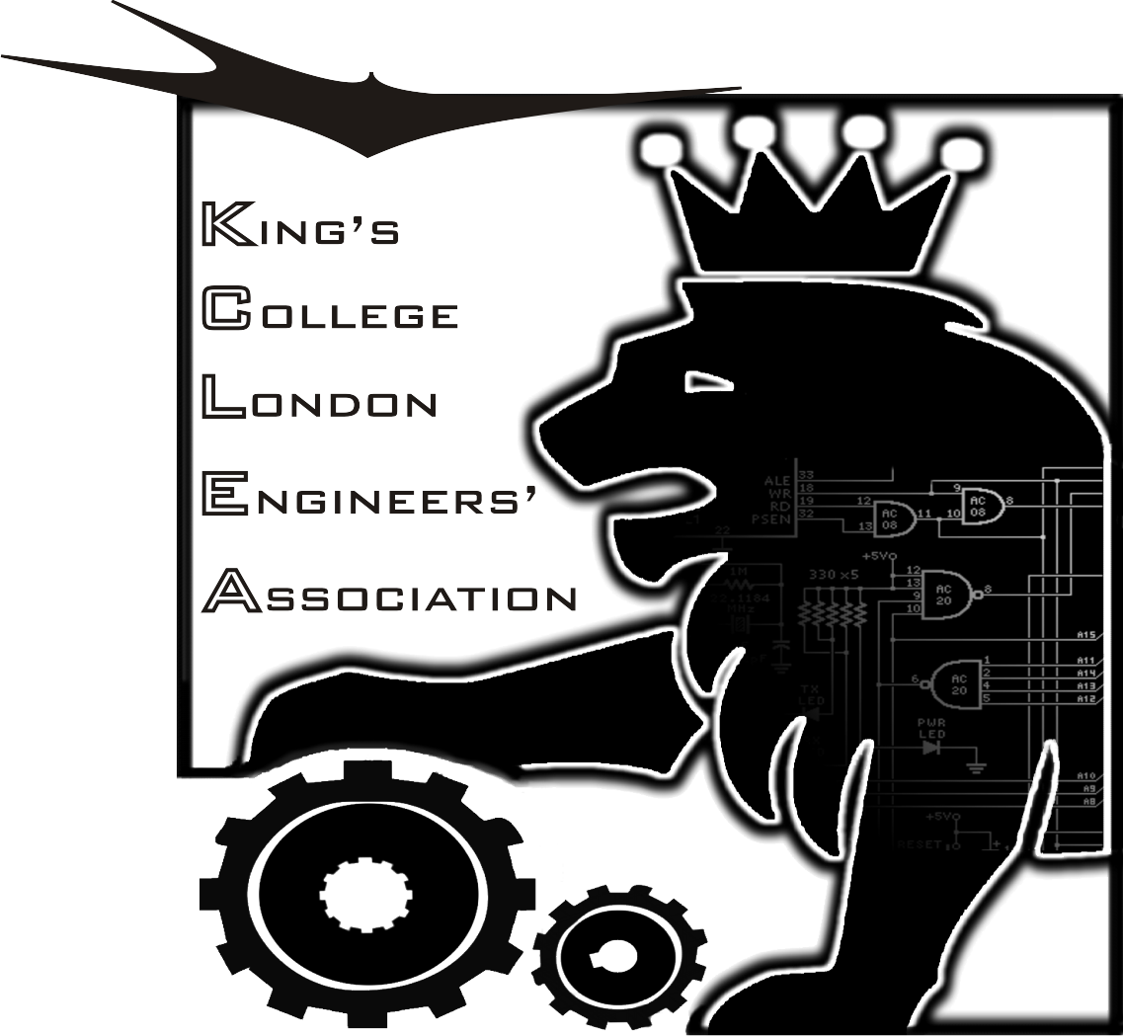
King’s College London
Engineers’ Association
(KCLEA)

MINUTES OF THE ANNUAL GENERAL MEETING
HELD ON FRIDAY 29th NOVEMBER 2019

Present
Graham Raven, Chris Bowden, John Thomson, Keith Newton, Tony Rudkin, Nicholas St. Hill, Mike Clode, Lai Cheung, David Blacoe, Bobby Dixit, Bill Shepherd, Tim Griffiths, Dave Potts, Simon Skinner, Keith Jaffay, Alastair Elder, Stephan Oates, David Sheridan, Agnimitra Saha, Nishanth Sastry, Krisian Chhatralia, Mahin Nasir, Graham Jones.
1.0 Apologies for absence
Barbara Shollock, Clive Arrigoni, Chris Sladden, James Aston, John Burton
2.0 Minutes of the 2018 AGM
These were approved.
3.0 Matters arising
Covered within the minutes of this meeting.
4.0 Officer’s reports
Our President, David Blacoe, presented his report which was as follows:-
We commenced the past academic year with the awards of two undergraduate bursaries of £1000. Also at the NMS Prize Giving Ceremony, last November, we presented two academic achievement medals, one in Biomedical Engineering and the other in Robotics.

The Annual Lecture, entitled “Cyberspace – Explainable Security” was given by Professor Luca Vigano on 27th February, highlighting the many challenges of staying ‘ahead of the curve’ in our online world. He is the Vice Dean (External Relations) in the Faculty of Natural & Mathematical Sciences.

Our Annual Engineers’ Lunch was held during the Alumni Weekend on 7th June in the Great Hall, with the newly appointed Head of Engineering, Professor Barbara Shollock, as our Guest Speaker. As she outlined, August 2019 is the official date for the re-establishment of the Department of Engineering, with the new General Engineering degree prospectus recently published.

We continue to nurture a close support of KCLES, following the election of their new officers earlier this year. They have an comprehensive plan for events this term, including external speakers, career feedback from recent graduates, internship panel, technology workshop, programming classes and of course some active social gatherings!

More details of KCLEA activities are available in the “King’s Engineer Bulletin – Autumn 2019”, which can be downloaded from our newly revived website www.kclea.org.uk.

On a sad note, in October our Honorary Auditor, Ian Williams, died after more than 25 years of dedicated commitment and wise council to KCLEA on all financial matters.

I would like to close by expressing my sincere thanks for the support and hard work by the Officers and Committee.
5.0 Accounts (including the Trustees report)
John Thomson, our Treasurer, outlined the current situation, relating to the audited accounts.
For 2019 the surplus of income over expenditure was £1,219. This compared with £1,449 in 2018.
Total net assets for 2019 were £63,979. This included £52,028 in the M&G Dividend Fund and £6,537 in the Nationwide account. For 2018 the corresponding figures were £66,282 £50,560, £11,258
On behalf of the Trustees Mike Clode provided the following summary:-
Tax issues are being checked out.
The KCLEA Bursary Fund (administered by the College) looks healthy with a capital of £56,078 as at 31st July 2019. The income received was £4,993. It was suggested that we could consider increasing the number of bursaries supported by this fund from 1 to 2.
John Thomson reminded us that our Constitution states that our accounts should be audited “by two Auditors”. It was proposed, and formally approved at this meeting, that this should be changed to read “by one Independent Examiner to be approved and appointed by the Committee.
- Nomination and Election of Officers and Committee Members
All Officers and Committee Members indicated their willingness to re-stand. This was proposed and accepted unanimously.
- Update on Engineering at King’s
A summary was presented on behalf of Professor Shollock by Nishanth Sastry (Senior Tutor). He highlighted the long history and legacy of Engineering at King’s. He then summarised the scope of the new General Engineering degree course which aimed to prepare students for the “real world” and be mindful of the needs of, and opportunities, provided by the 3rd world. He illustrated this by referring to a project in Cameroon.
Our attention was drawn to the massive new infrastructure work in the quad.
Interaction with and input from the KCLEA was invited, particularly as regards project orientated input.
- KCLEA
- The Annual Lecture
As mentioned in the President’s report the 2019 lecture was delivered by Professor Luca Vigano on the topic of cybersecurity.
David Sheridan, who was present at the meeting and was introduced by Bobby Dixit, has been invited to present the 2020 lecture. Details are yet to be finalised but the theme will have synergy with the new General Engineering Degree course.

- The Annual Lunch
We were somewhat down on numbers as regards attendance at the 2019 Lunch. Planning for the 2020 Lunch is in progress and is currently expected to take place on Saturday 13th. June.
- Communication with Members
Graham Raven, our Membership Secretary outlined the situation. Our prime source of data is currently the alumni data base, which is constrained by rather cumbersome rules and regulations. Some simplification is being negotiated with the KCLA, which should read across to us.
Graham was thanked for his work.
- KCLES
Mahin Nasir, President of the KCLES, was confirmed as our “ex-officio” Vice President. She then gave us a summary of the KCLES which is very active including many good events and talks by engineering alumni. One of Mahin’s objectives is to encourage students from all types of engineering to be part of the KCLES as the current membership is predominantly Biomed students. Mahin also wants to encourage the interaction between KCLEA and KCLES.
- KCLEA Bursaries and Medals
The bursaries were awarded to Krisian Chhatralia and Agnimitra Saha who were both in attendance and congratulated by the meeting.
The medals, which had been presented at the NMS prizegiving, have been awarded to Rasmita Kearle and Eylul Ceylan.
11.0 The 13 Club Trophy
This was awarded to John Thompson in recognition of his work in developing our new website. John was presented with his Medal.
12.0 AOB
Keith Newton reminded us that a Timeline of Engineering at King’s had been prepared at the time of the proposed 2013 closure of Engineering. He has a data base of many alumni. It was proposed that they be invited to provide a potted biography of their careers.
David Blacoe mentioned that King’s has called for a Global Day of Service with an invite to all Alumni to take part in the week 23rd – 27th March. Maybe KCLEA could support this?

